ALDELO | SMARTBIZPOS RESTAURANT
Overall  - 100% Touch Operated Point of Sale  - Simple to Use Back Office Operations  - Super Easy and Intuitive Screen Layout and Work Flow  - Multilingual User Interface Support Out of the Box (English / Spanish / Chinese)  - Supports Dual Language Menu Input and Handling  - Fully Compatible with Windows XP Pro, WEPOS, Vista, Win 7, and Server 2003 & 2008  - Works Great on Both 32 Bit and 64 Bit Windows Operating Systems  - Behind the Scene Operations Logging To Ease Store Operators Security Concerns  - and more...  Point of Sale  - Menu Item Ordering Achieved With Just One Click  - Automated Menu Item Tag Along Supports Combo Meals  - Easily Hold and Fire Orders  - Specialized Pizza Builder Makes Pizza Ordering a Breeze  - Specialized Forced Modifiers Ensure Fast Item Completion  - Effortless Order Split and Combine  - Integrated Weight Scale Support Enhances Productivity  - Point of Sale Designed Specifically For Table Service, Quick Service and Bar Operations  - Support for Carry Out and Drive Thru  - Support for Bar Tab Operations  - and more...  Seating Management  - Graphical Table Management  - Reservations and Waiting List Management  - Guest Count Tracking  - and more...  Delivery and Routing  - Clearly View the Status of Delivery Orders On Route  - Easily Dispatch Drivers For Delivery Orders in Queue  - MapPoint Integration Support For Simplified Visual Map and  Turn By Turn Instructions  - Support For Delivery Driver Timing Tracking  - Handles Driver Money Drop and Compensation  - and more...  Financial Accountability  - Full Cashier Support To Ensure Every Penny is Accounted For  - Staff Banking Capability To Support Fine Dining Operations  - Pay Out Feature That Simplifies Out of Register Expenses  - Cashier Liability Report and Shift End Report Enhances Accountability  - Multiple Payment Tender Types Supported  - Integrated Payment Processing through Aldelo EDC Supported  - and more...  Customer Management  - Simple To Use Customer Profile and Order History Tracking  - In Store Credit Creation, Redemption and Balance Tracking  - In Store Gift Card Creation, Redemption and Balance Tracking  - In Store Frequent Buyer Program Tracking and Rewards  - In Store House Charge Account Tracking and Payments  - In Store Customer Incident Tracking  - and more...  Workforce Management  - Fully Integrated Employee Time Card Tracking System  - Easy To Manage Employee Work Schedules  - Quick and Easy Employee Payroll Preparation Report  - Productive Staff Communication via Local Messaging and Text Pagers  - and more...  Inventory and Recipes  - Complete Inventory Management Capabilities Out of the Box  - Complete Recipe Management Capabilities Out of the Box  - Automatic Purchase Order Creation Based On Inventory Levels  - Detailed Inventory Reports To Help Identify Costs and Increase Bottom Line  - Support For Physical Inventory Counts  - Support For Inventory Receiving Verification Work Flow  - and more...  Extensive Reporting  - Detailed Sales and Operations Reports Provided  - Detailed Financials Accountability Reports Provided  - Detailed Customer Reports Provided  - Detailed Employee Reports Provided  - Detailed Inventory Reports Provided  - and more...  Third Party Extensibility  - System Integration SDK Allows ISV to Build Bi-Directional Value Added Solutions  - TCP Packet Notification SDK Allows ISV to Build Solutions That React To POS Events  - Folio Payment SDK Allows Hotel Solutions to Provide Room Charge Inquire and Posting Links  - Order Finalization SDK Allows ISV to Extend Order Settlement and Fiscal Tracking Needs  Industry Certifications and Validations  - PA-DSS Validation Helps Merchants Comply with PCI Regulations  - NTEP Weight Scale Certification Ensures Compliance with State Laws  - Windows 7 Compatibility Validation Ensures Proper Operation | Overall  - Yes, to be done for Management Module  - Yes, to modify for Management menu  - Yes, to modify for Management menu  - Yes, Primary is English, Secondary is Vietnamese.  - Yes  - Yes  - Yes  - Yes, for Exemption Report, to modify Reports  Point of sales  - Yes  - Yes , to add Option and Special Request butons  - Yes, to add “Kitchen Hold” button  - No  - Yes, to add Option price modifier  - Yes, merge and split table  - No  - Yes, with Kitchen Monitor “đặt hàng” & “dọn bàn”  - Not yet, will supports Google Map  - Yes  Seating Management  - Yes  - Yes, to be done  - Not yet, need to add  Delivery and Routing  - Not yet, need to add for Premium Pack  - Not yet, need to add for Premium Pack  - Not yet, need to add for Premium Pack  - Not yet, need to add for Premium Pack  - Not yet, need to add for Premium Pack  Financial Accountability  - Yes  - No (mitigate → Promotion)  - Yes  - Yes  - Credit card(s), Cash, Check, Gift Card  - Integrated with SmartBizERP (Premium Pack)  Customer Management  - Yes  - Promotion  - Promotion  - Promotion  - Promotion  - Need to add for Exemption Management  Workforce Management  - Not yet, Need to have Phase 1  - Yes  - Just report of cashier timesheet  - Not yet, need to add for Premium Pack  Inventory and Recipes  - Yes  - Yes (yêu cầu mua nguyên liệu)  - Not yet, for Premium Pack only  - Yes  - Yes  - Not yet, for Premium Pack only  Extensive Reporting  - Yes, including giftcard, membership, loyalty program  - Yes  - Yes  - Yes  - Yes  Third Party Extensibility  - No  - Yes , to be done  - Not yet, for Premium Pack only  - Not yet, need to add for Fiscal Report software  Industry Certifications and Validations  - Not yet  - Not yet  - Not yet OK
Mobile Application
- Runs on iPhone, iPad, Android, PDA
Customer Register with Product ID and Activation Key
- Online (www.epostouch.com)
  - 30 days trial or Purchased onlin with credit card

- Appointment: Màn hình chính: view reservation
  - Restaurant combo-box: Multiple Calendar.
  - Time of Day – shift:
  - Tables – Location – list box.
  - Covers: so nguoi
  - Preferences: Remark
  - Retrieve current calendar.
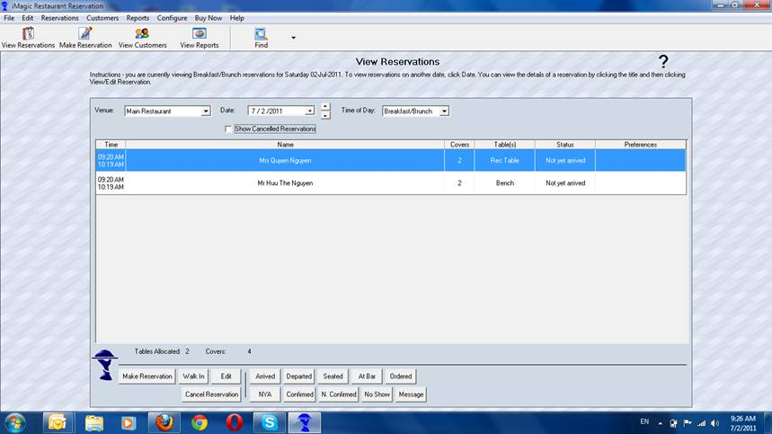

- Make a reservation => điền thong tin và bấm “Check-availability” để check bàn trống:
  - User info – Google Contact.
  - Similar to – create new event in GC.
  - Tables List: Table name + covers + notes + Floors.
  - Tables & Floors – using SunflowerVN-ManagerService – MySQL.
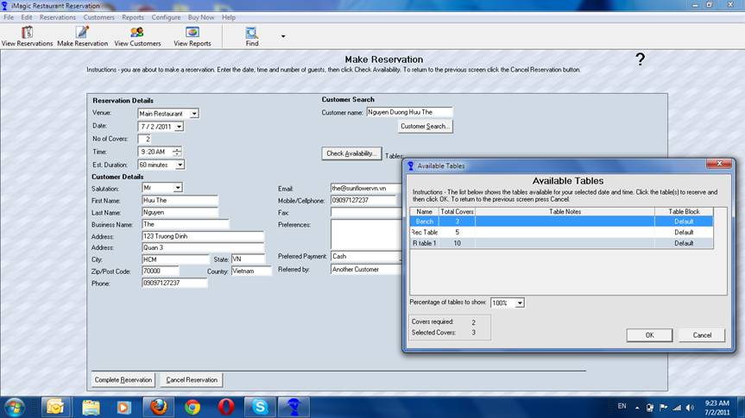

- Thay đổi tình trạng : arrived, seated
    - Update status
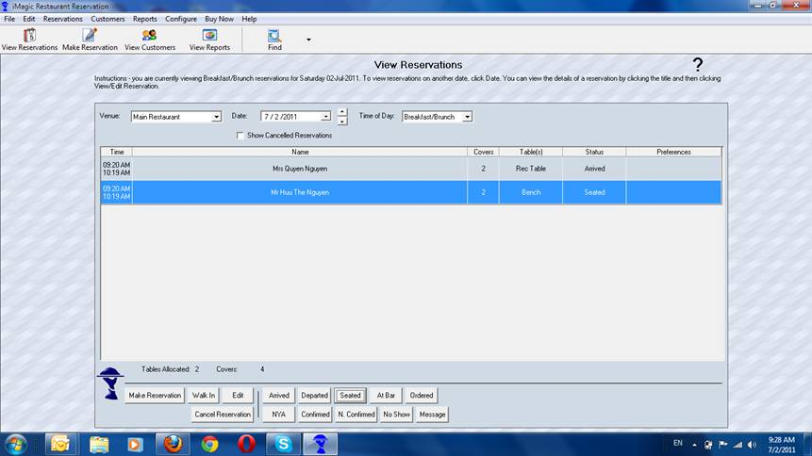

- Báo cáo:
    - Template + JasperReport: SunflowerVN
    - SQL + integrate.
